PRESS RELEASE

First released 24 August 2022
Updated 25 August 2022 11:00 am

Megawide donates new fire station to Taytay

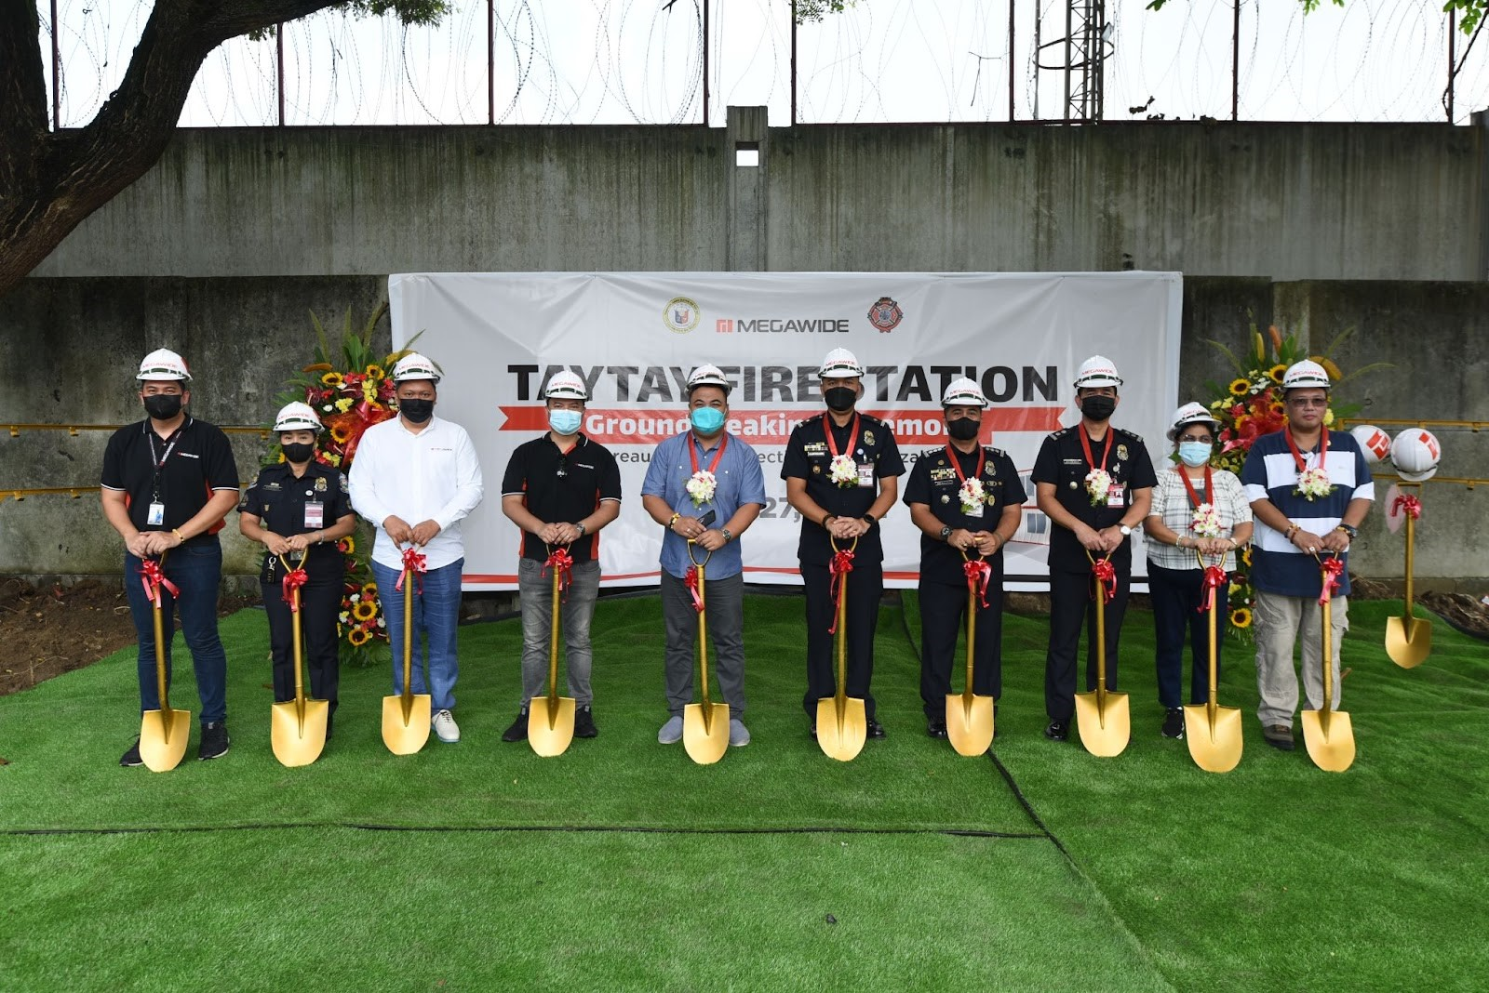
(L-R: Megawide Safety Manager Christopher Tamayo, SFO3 Rowena Remigio, Megawide AVP for Precast Jeralbine Nuguid, Megawide Facilities Manager Ruel Alma, Taytay Mayor Allan De Leon, FINSP Gary Raymond Cantillon, FSSUPT Andrew Mendova, FSUPT Crispulo Eusebio, Jr., Municipal Chief Assessor Connie Viray and MDRRMO Head Alvin De Leon)

Megawide Construction Corporation (“Megawide” or “the Company”) and the Bureau of Fire Protection-R4A (BFP R4-A) broke ground last July 27 for a brand-new fire station in Taytay, Rizal. The facility will cost around P3.2 million, including the land, structure, and other related works, and will be a donation of Megawide to the community.

Located in a 200-square meter lot in Brgy. San Juan, Taytay, Rizal, the building is expected to boost the municipality’s emergency response in cases of fire and other emergencies. The groundbreaking ceremony, which signals the start of construction, was led by the officials of BFP Taytay and Megawide.

“Megawide’s vision to engineer a First-World Philippines also extends to helping local governments provide better public service through emergency response infrastructure. We aim to deliver this new fire station on time, using our precast and construction solutions capabilities,” said Megawide Executive Vice-President for Business Units Markus Hennig.

Megawide will undertake the site, structural, and civil works, including mechanical, electrical, plumbing and fire protection (MEPF) services.

“We want to express our utmost appreciation to Taytay LGU and Megawide for their consistent support to the agency. This new fire station, which is strategically located within highly populated areas and other high-risk spaces, will provide easier access for fire suppression and rescue operations and be a great help to complement our initiative of ramping up fire safety in the municipality,” said Taytay Bureau of Fire Protection Chief Gary Raymond Cantillon.

“The new fire station will also bolster the morale, effectiveness and responsiveness of every personnel of the station. We believe that a more conducive working environment will result in a more responsive and efficient output from any employee or personnel,” he added.

Megawide’s industrial facility is located in Taytay and houses its main Precast Plant, formworks warehouse, and motorpool. Megawide has continuously worked with its partner communities and key stakeholders to promote an effective and sustainable corporate social responsibility (CSR) platform. END

Refer to:
Anna Salgado
asalgado@megawide.com.ph
09175637629

ABOUT MEGAWIDE
Megawide is one of the leading infrastructure and engineering innovators in the Philippines. Publicly-listed since 2011, it is one of the largest contractors for private sector construction projects in the country and the private partner of the Philippine Government for flagship infrastructure projects such as the development of the Mactan-Cebu International Airport (MCIA) and the Paranaque Integrated Terminal Exchange (PITX).

Megawide is also the sole construction partner for the Clark International Airport New Passenger Terminal Building. It is currently undertaking the construction of the Malolos-Clark Railway Project Package 1, and the modernization of Cebu’s historic Carbon Market District. In 2012, the company established Megawide Corporate Foundation, Inc., a non-profit organization focusing on social development projects.

